Datasets, Generalization, and Overfitting
Introduction
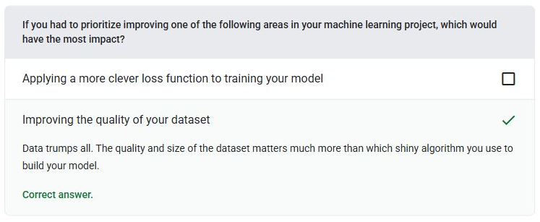
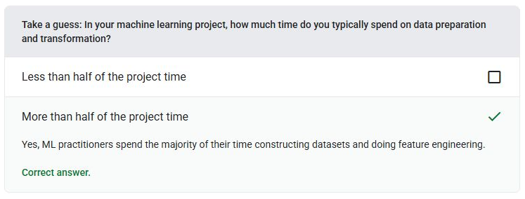
Data Characteristics
Dataset - A collection of raw data.
Embedding Vector - Broadly speaking, an array of floating-point numbers taken from any hidden layer that describe the inputs to that hidden layer.
Example - The values of one row of features and possibly a label.
Feature - An input variable to a machine learning model.
Model - In general, any mathematical construct that processes input data and returns output.
Value Imputation - The process of replacing a missing value with an acceptable substitute.
Z-score Normalization - A scaling technique that replaces a raw feature value with a floating-point value representing the number of standard deviations from that feature's mean.
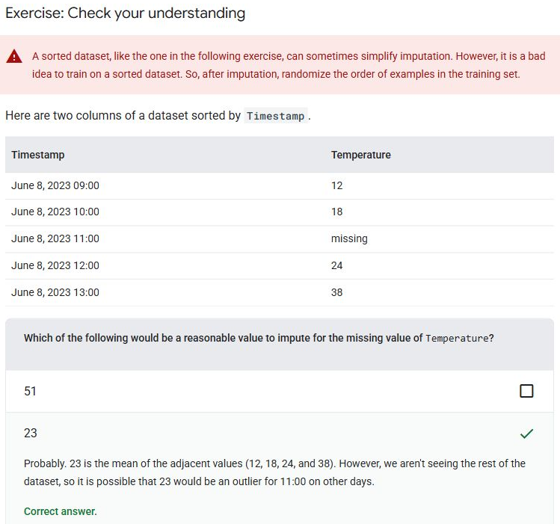
Labels
Label - In supervised machine learning, the "answer" or "result" portion of an example.
Feature Vector - The array of feature values comprising an example.
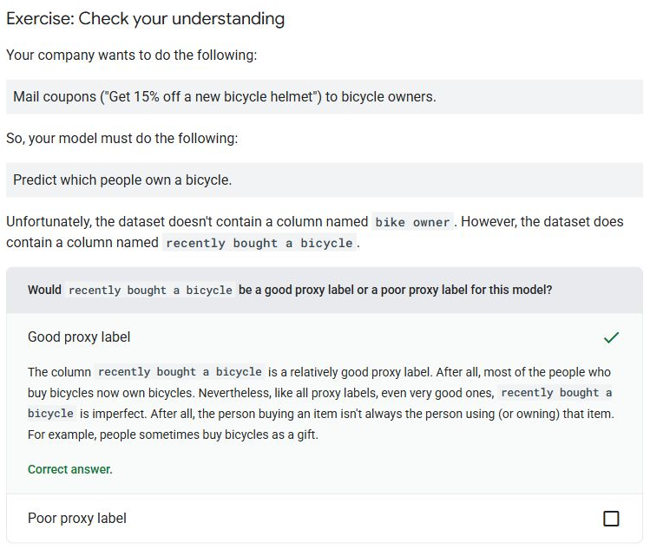
Imbalanced Datasets
Batch - The set of examples used in one training iteration.
Class-balanced Dataset - A dataset containing categorical labels in which the number of instances of each category is approximately equal.
Class-imbalanced Dataset - A dataset for a classification in which the total number of labels of each class differs significantly.
Dataset - A collection of raw data.
Downsampling - Training on a disproportionately low percentage of majority class examples to improve model training on minority class examples.
Hyperparameter - The variables that you or a hyperparameter tuning service adjust during successive runs of training a model.
Majority Class - The more common label in a class-imbalanced dataset.
Minority Class - The less common label in a class-imbalanced dataset.
Prediction Bias - A value indicating how far apart the average of predictions is from the average of labels in the dataset.
Upweighting - Applying a weight to the downsampled class equal to the factor by which you downsampled.
Dividing the Original Dataset
Test Set - A subset of the dataset reserved for testing a trained model.
Training Set - The subset of the dataset used to train a model.
Validation Set - The subset of the dataset that performs initial evaluation against a trained model.
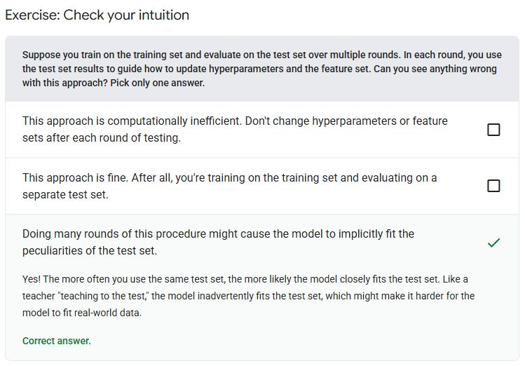
Exercise 2
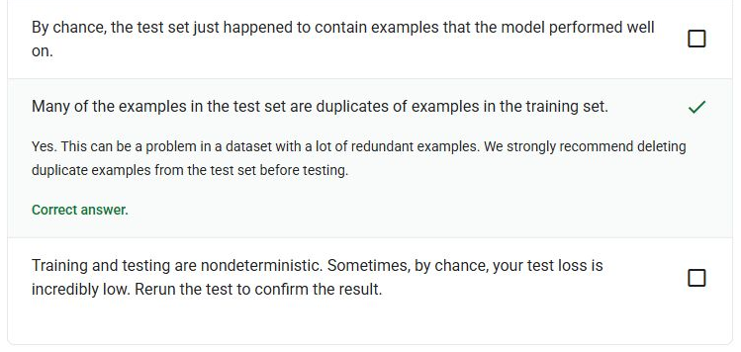
Exercise 3
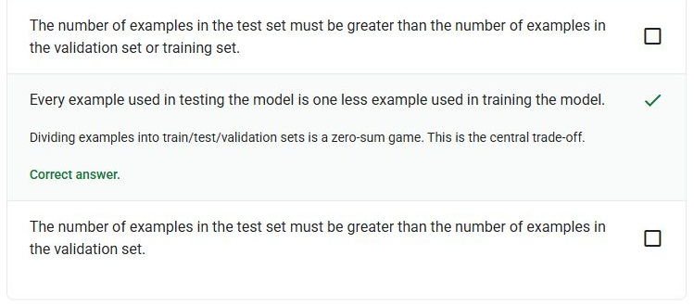
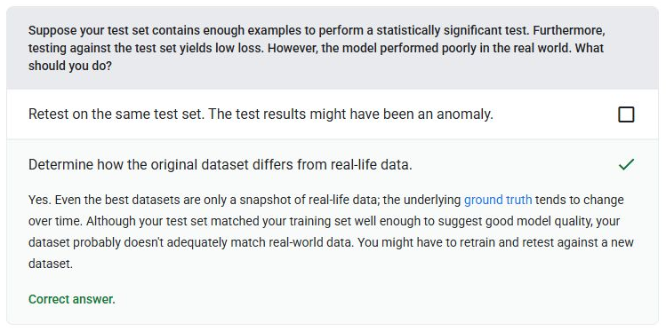
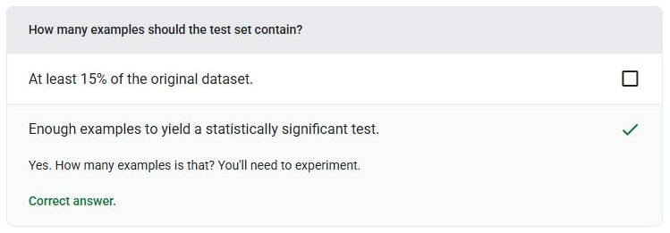
Transforming Data
Normalization - Converting a variable's values into a standard range, such as -1 to +1, 0 to 1, or Z-scores.
Generalization
Overfitting
Feedback Loop - In machine learning, a situation in which a model's predictions influence the training data for the same model or another model.
Generalization - A model's ability to make correct predictions on new, previously unseen data.
Generalization Curve - A plot of both training loss and validation loss as a function of the number of iterations.
Independently and Identically Distributed (i.i.d) - Data drawn from a distribution that doesn't change, and where each value drawn doesn't depend on values that have been drawn previously.
Loss Curve - A plot of loss as a function of the number of training iterations.
Overfitting - Creating a model that matches the training data so closely that the model fails to make correct predictions on new data.
Stationarity - A feature whose values don't change across one or more dimensions, usually time.
Training Set - The subset of the dataset used to train a model.
Underfitting - Producing a model with poor predictive ability because the model hasn't fully captured the complexity of the training data.
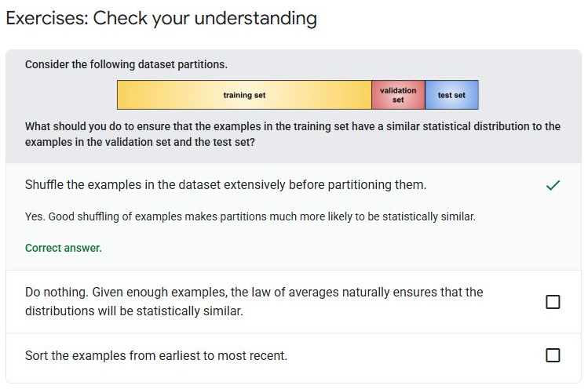
Exercise 2
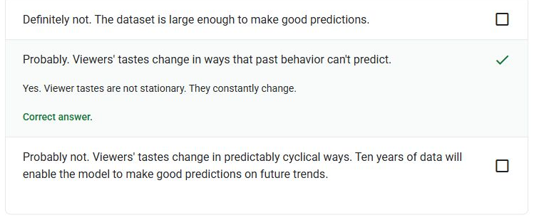
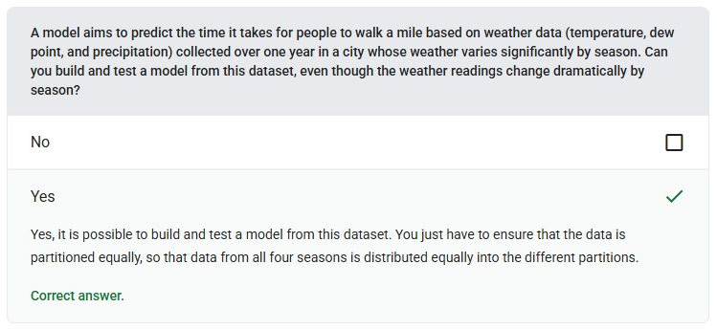
Model Complexity
L1 Regularization - A type of regularization that penalizes weights in proportion to the sum of the absolute value of the weights.
L2 Regularization - A type of regularization that penalizes weights in proportion to the sum of the squares of the weights.
Regularization - Any mechanism that reduces overfitting.
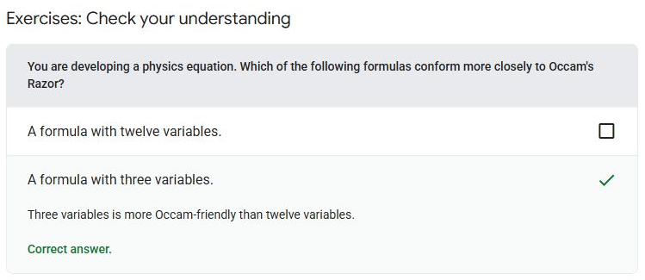
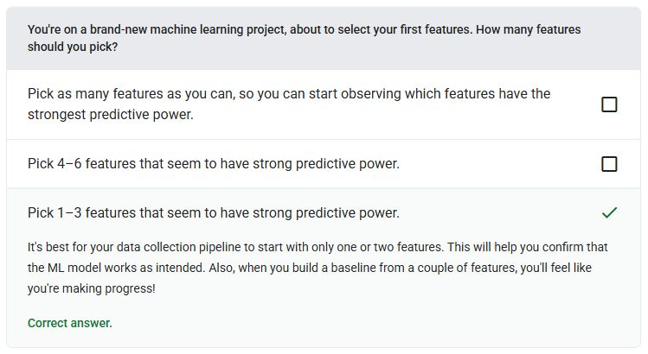
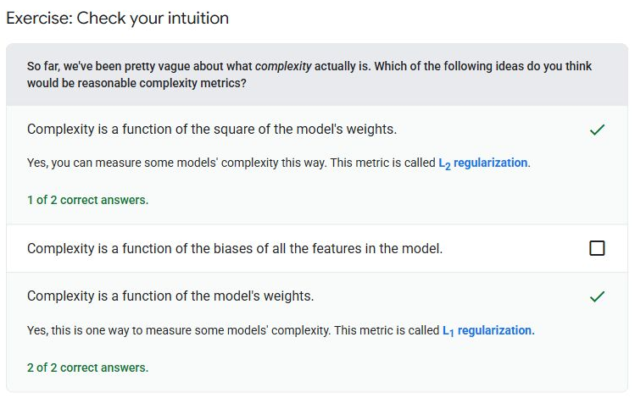
L2 Regularization
Early Stopping - A method for regularization that involves ending training before training loss finishes decreasing.
L1 Regularization - A type of regularization that penalizes weights in proportion to the sum of the absolute value of the weights.
L2 Regularization - A type of regularization that penalizes weights in proportion to the sum of the squares of the weights.
Learning Rate - A floating-point number that tells the gradient descent algorithm how strongly to adjust weights and biases on each iteration.
Regularization - Any mechanism that reduces overfitting.
Regularization Rate - A number that specifies the relative importance of regularization during training.
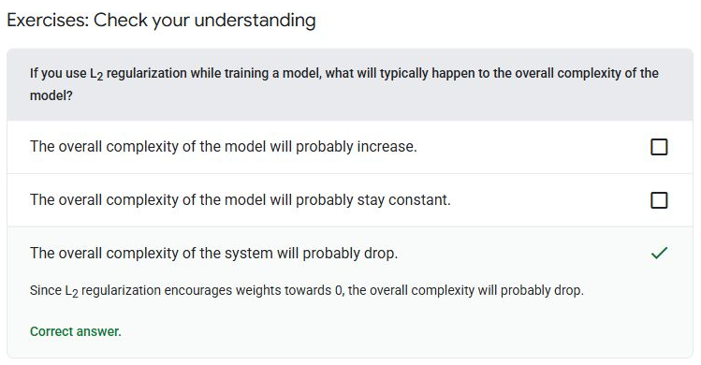
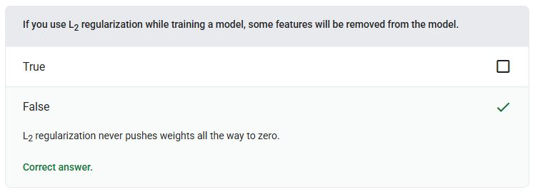
Interpreting Loss Curves
Batch - The set of examples used in one training iteration.
Example - The values of one row of features and possibly a label.
Feature - An input variable to a machine learning model.
Learning Rate - A floating-point number that tells the gradient descent algorithm how strongly to adjust weights and biases on each iteration.
Loss Curve - A plot of loss as a function of the number of training iterations.
Outliers - Values distant from most other values.
Overfitting - Creating a model that matches the training data so closely that the model fails to make correct predictions on new data.
Regularization - Any mechanism that reduces overfitting.
Regularization Rate - A number that specifies the relative importance of regularization during training.
Test Set - A subset of the dataset reserved for testing a trained model.
Training Set - The subset of the dataset used to train a model.
Validation Set - The subset of the dataset that performs initial evaluation against a trained model.
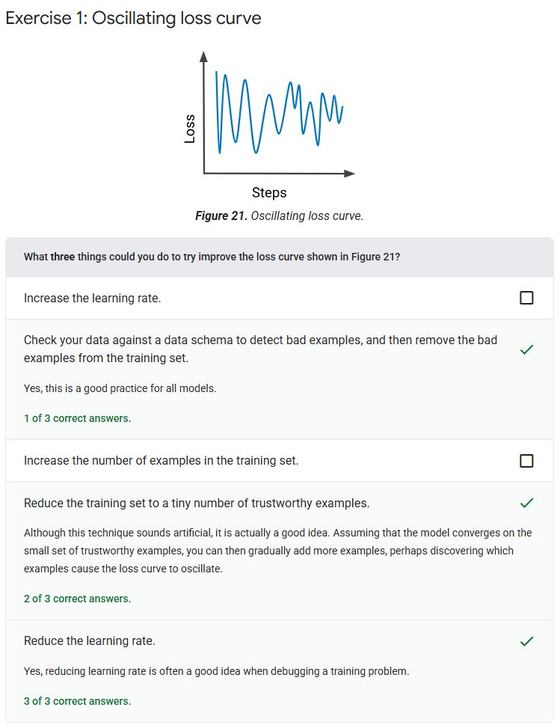
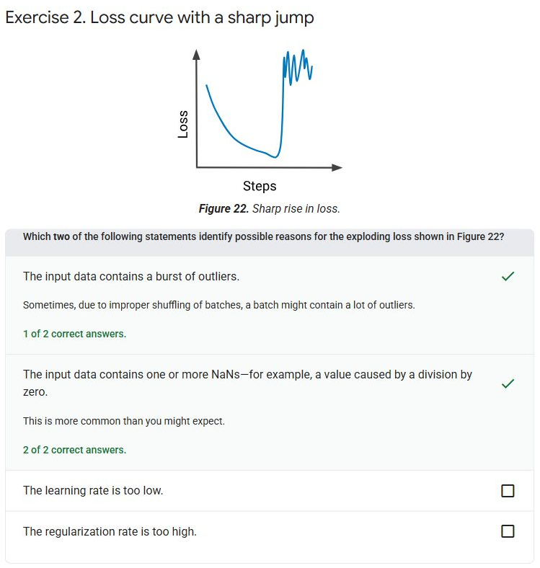
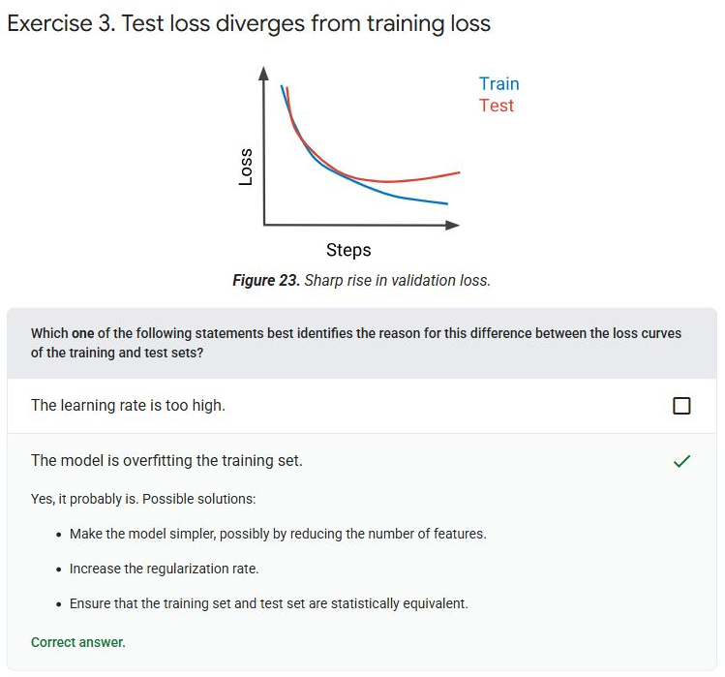
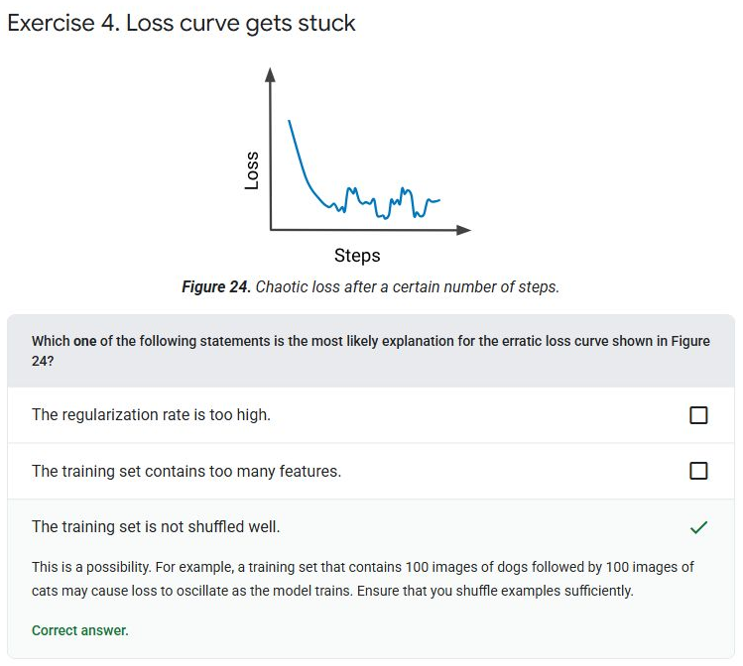
Test Your Knowledge


